Data Base Report

***PART (1)***

***DATABASE MODELLING & SQL***

* Q)1.1: This is how I designed the ERD.

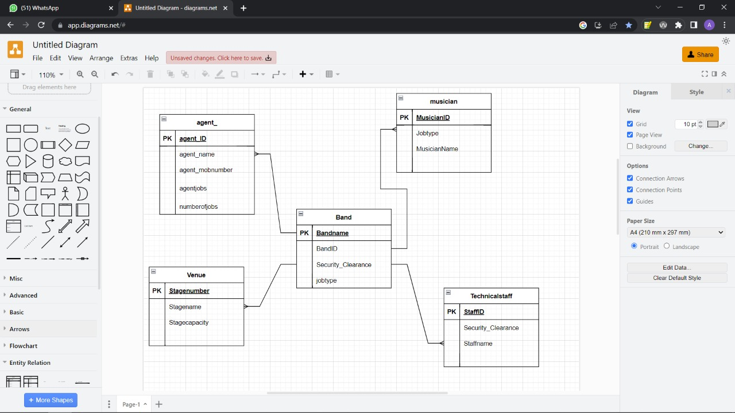

* **Q)1.2:** This is how we create the Tables.

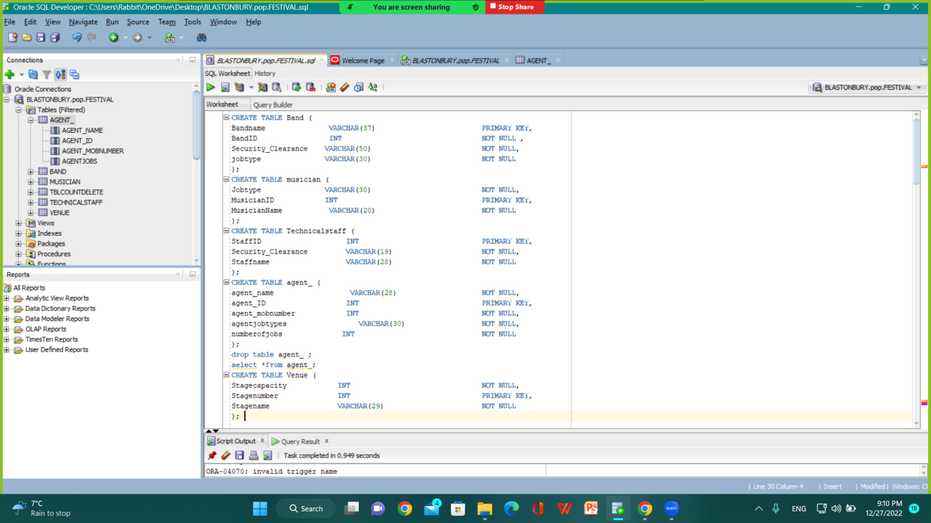

* **Q)1.3:** This is how i inserted the Values.

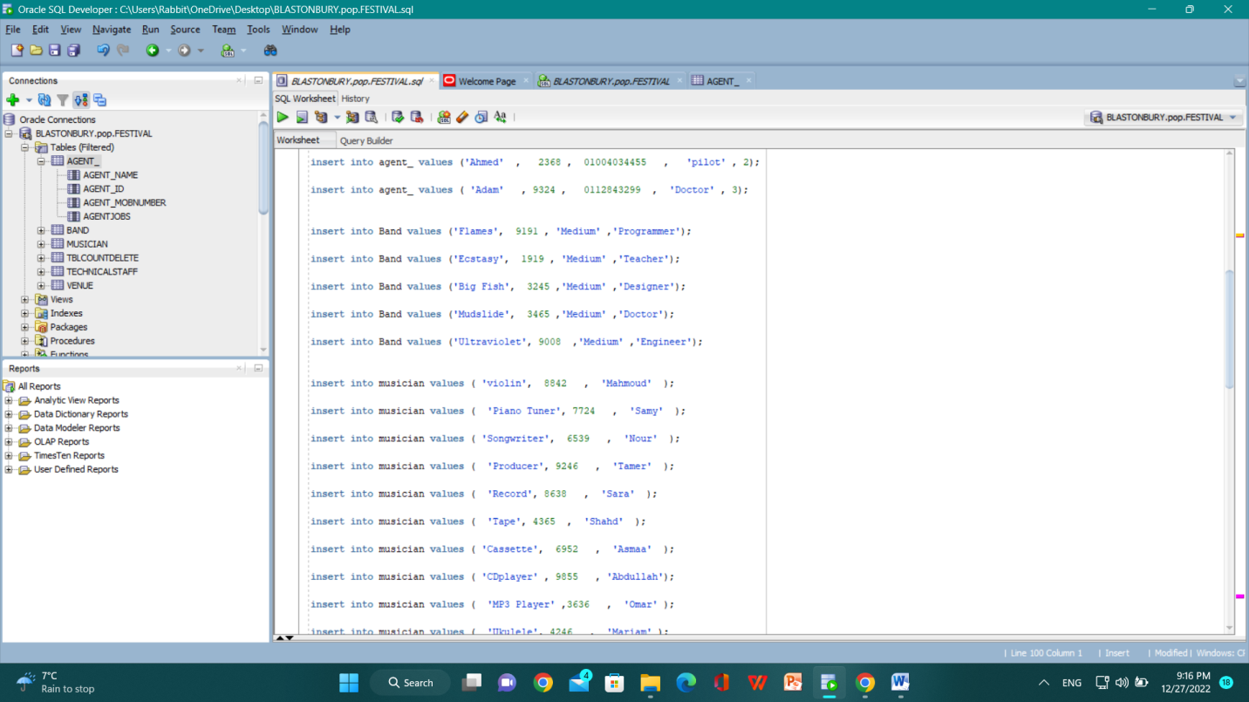

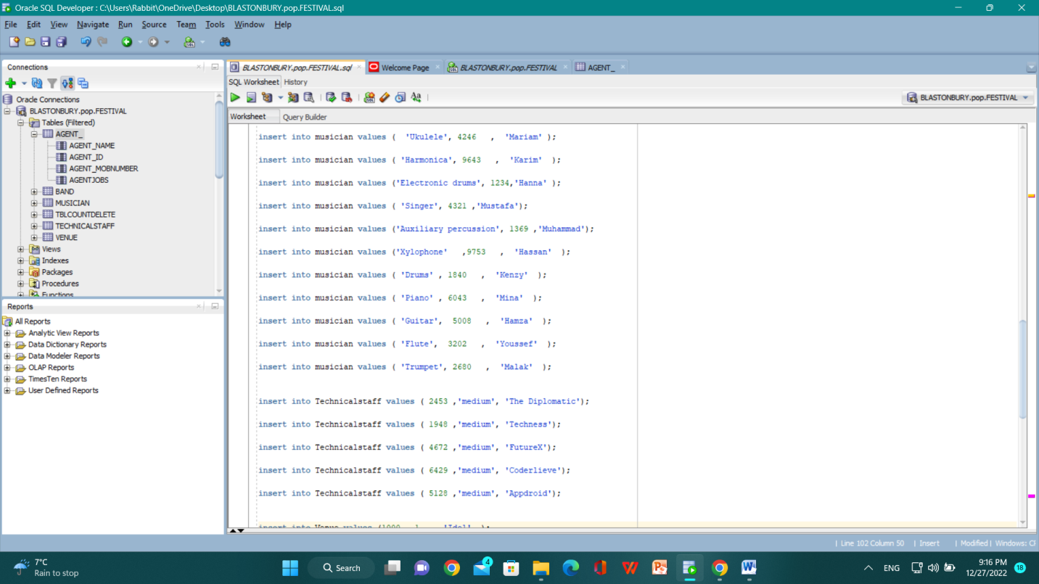

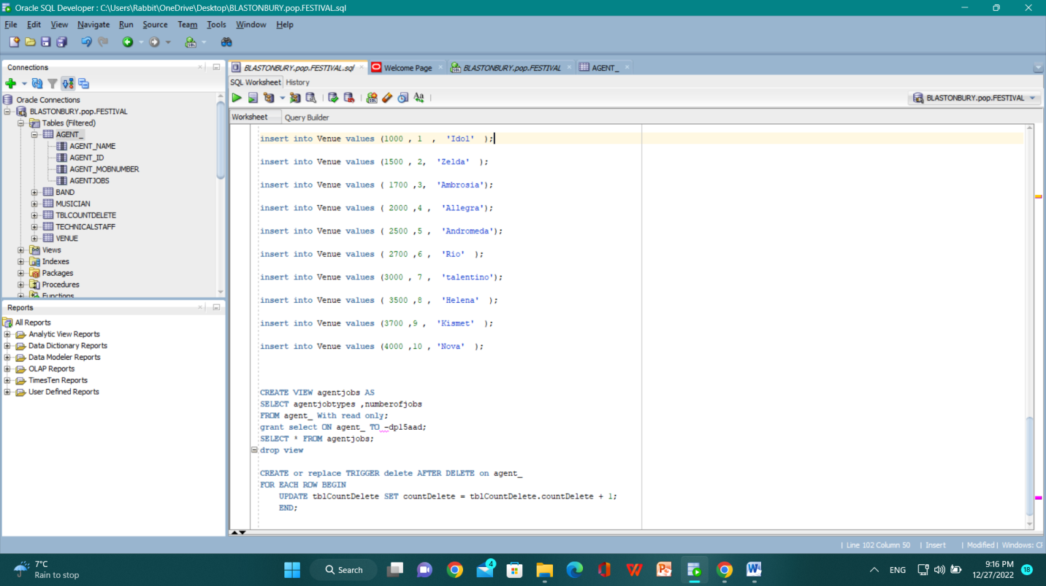

* **Q)1.4:** This is how to create SQL View.

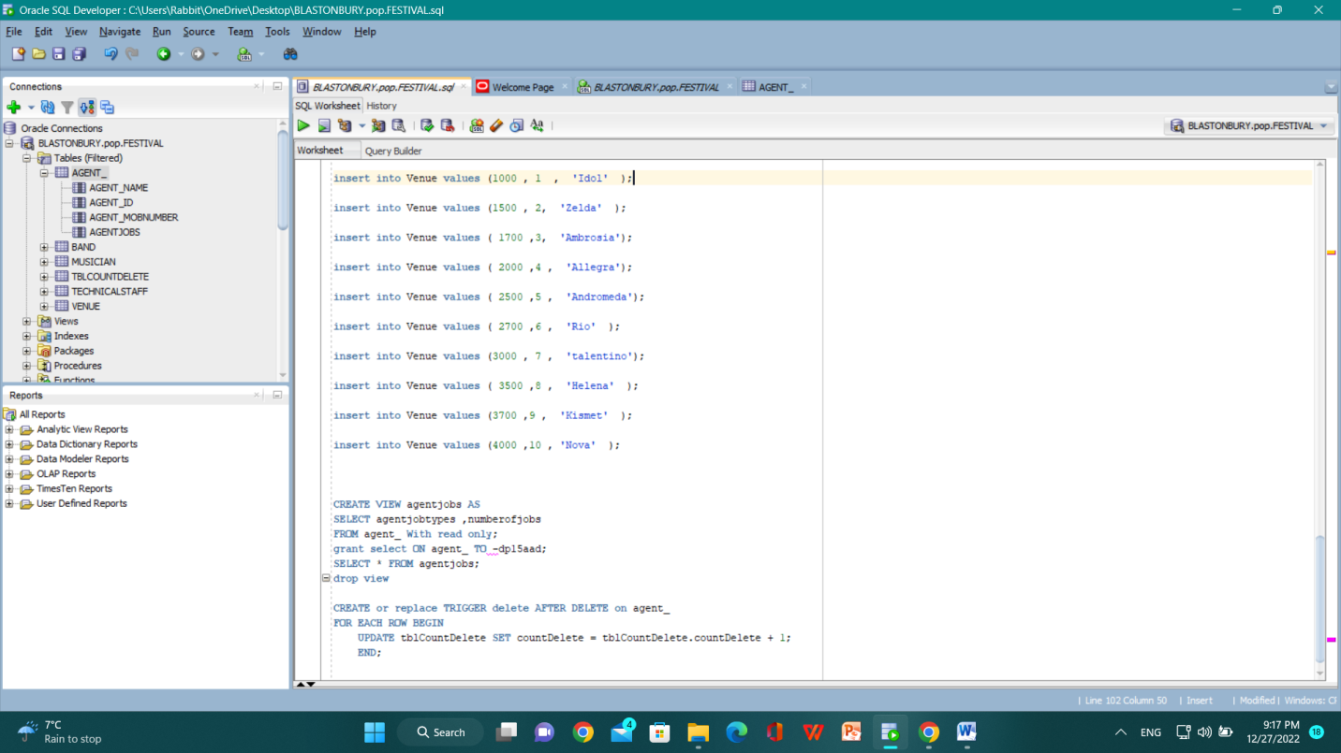

* **Q)1.5:** This is how to create SQL Trigger.

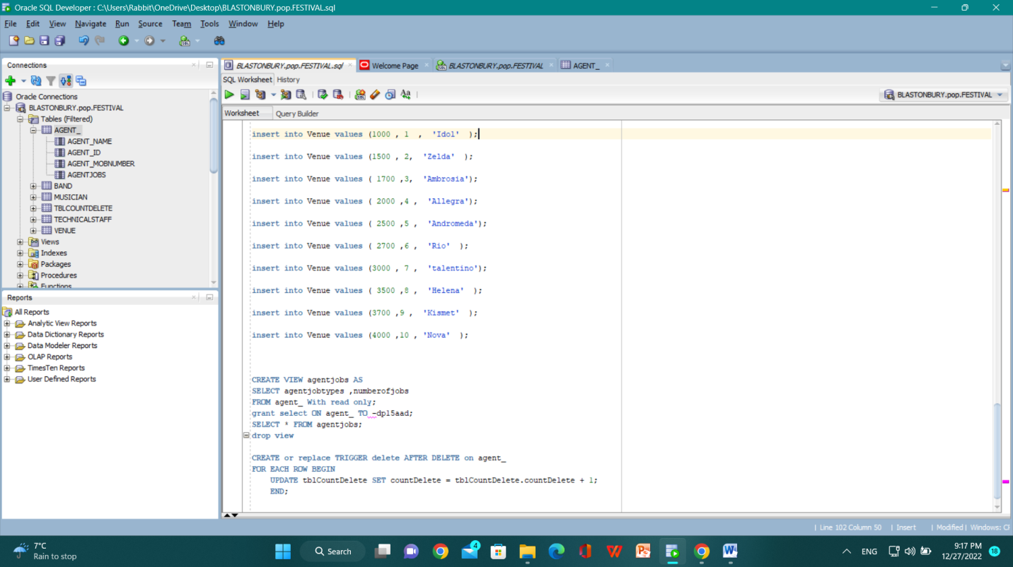

**PART (2)**

**MYSQL & PHP**

**Q)2.1:** Moving the data base to MYSQL .

I have copied the code from SQL developer to MYSQL.

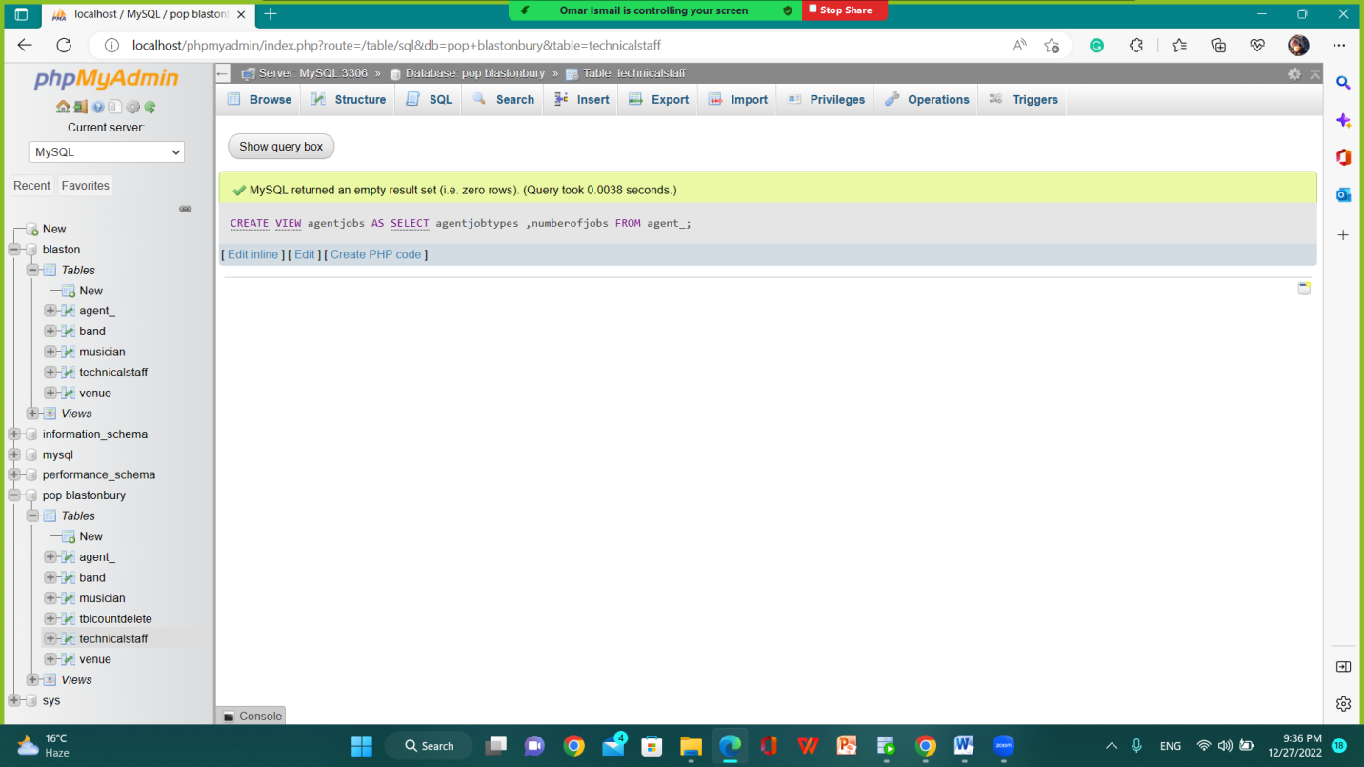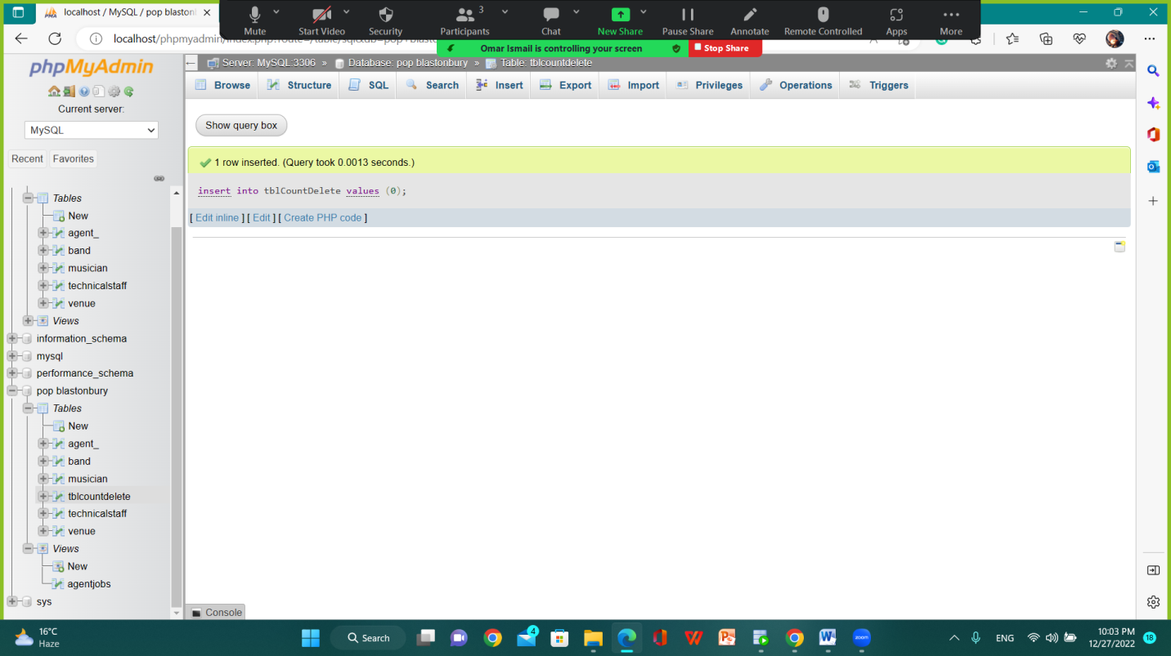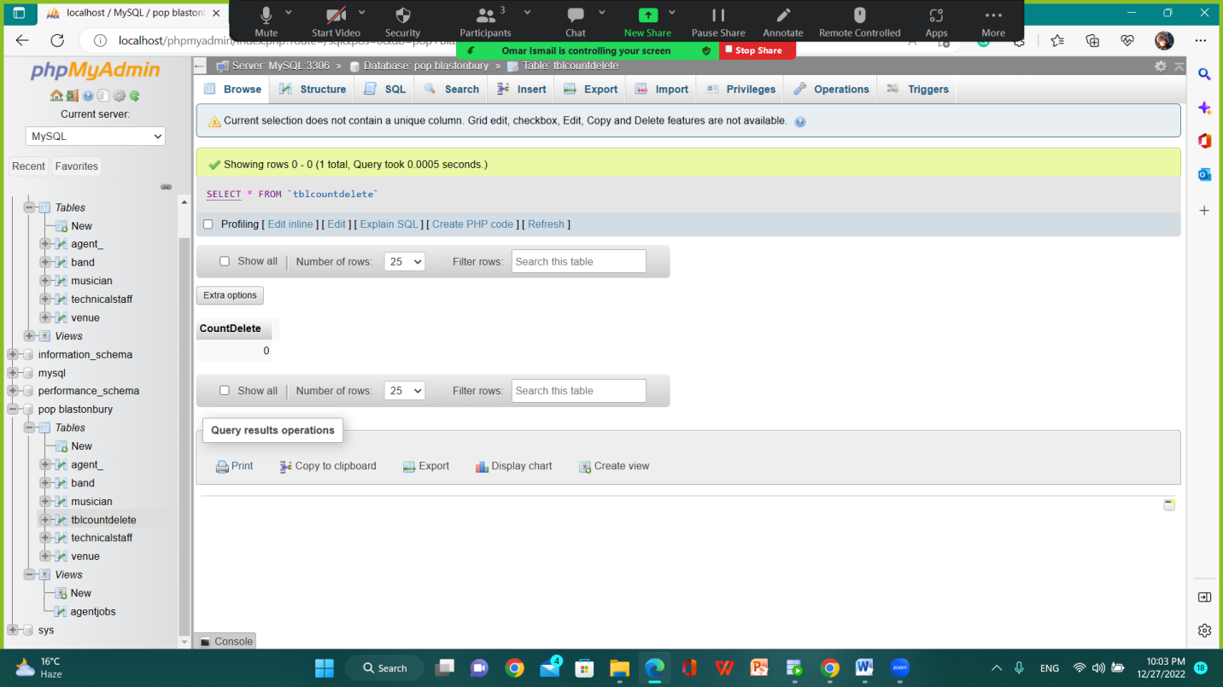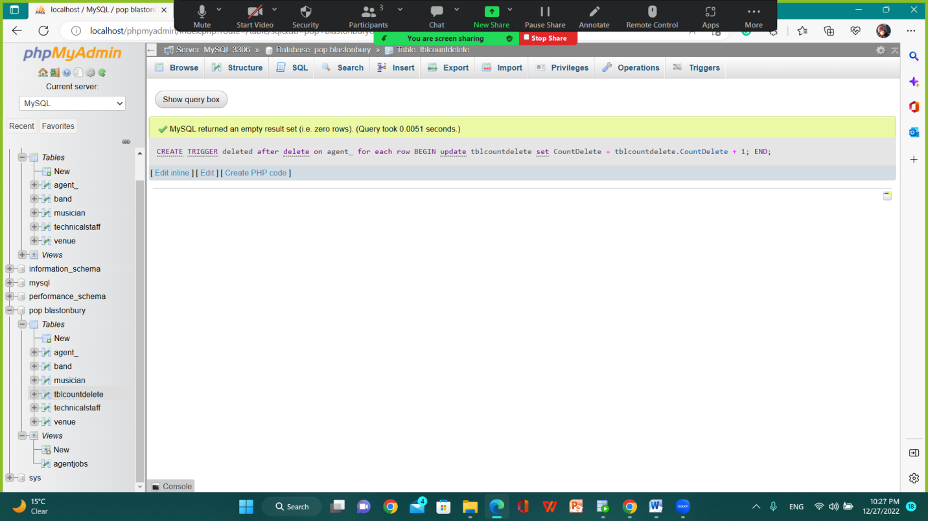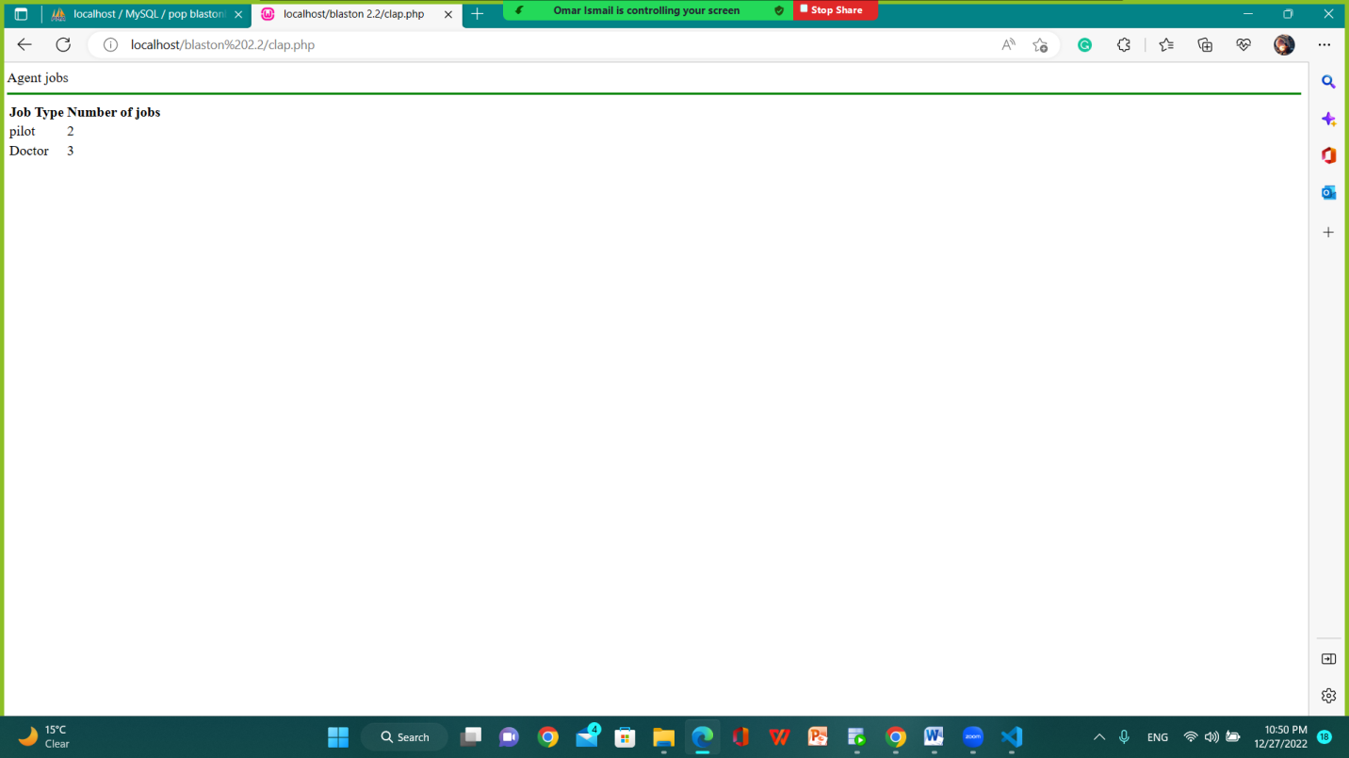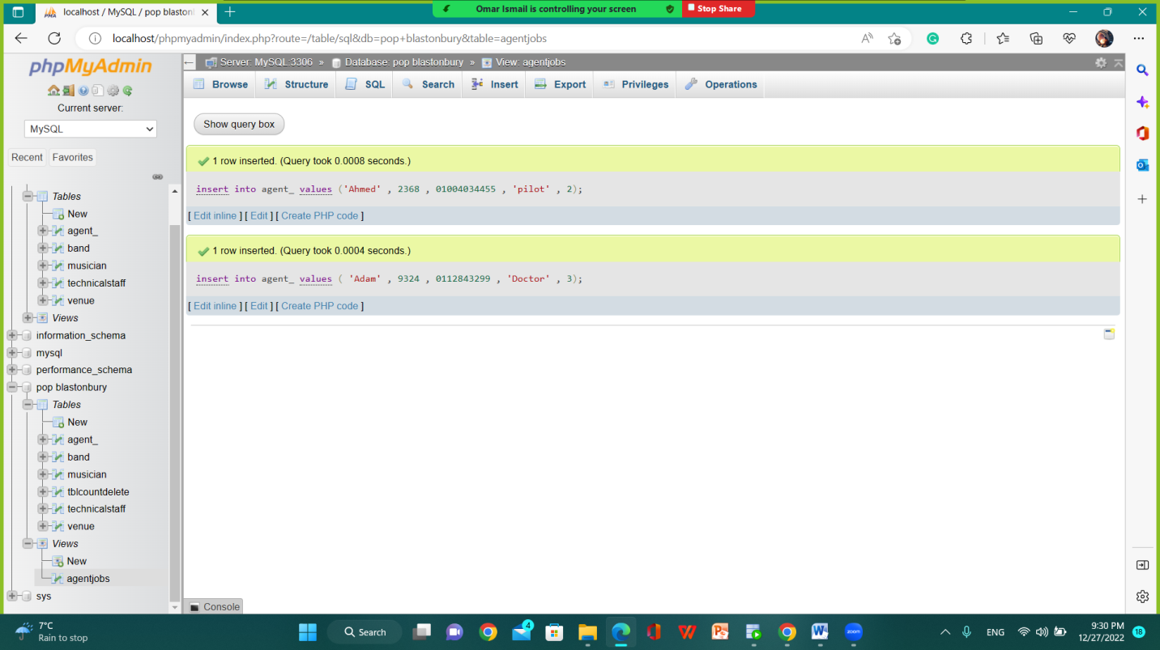

* **Q )2.2:** FETCHING DATA IN PHP.

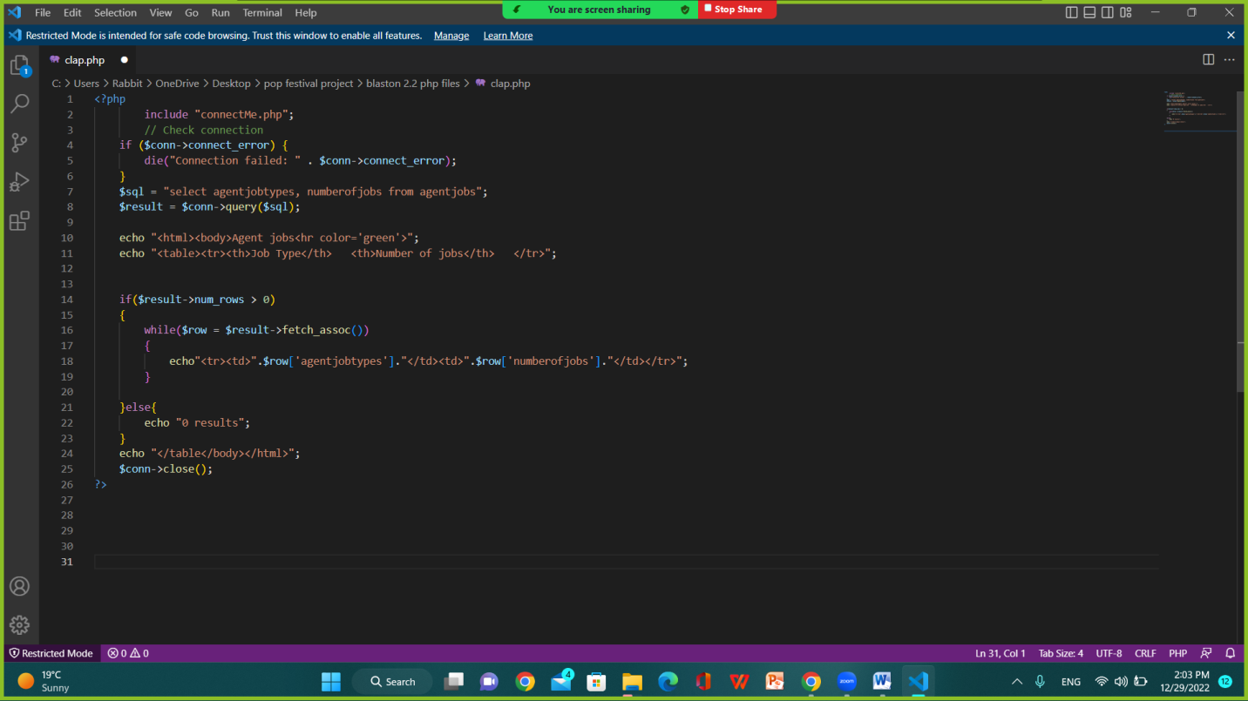

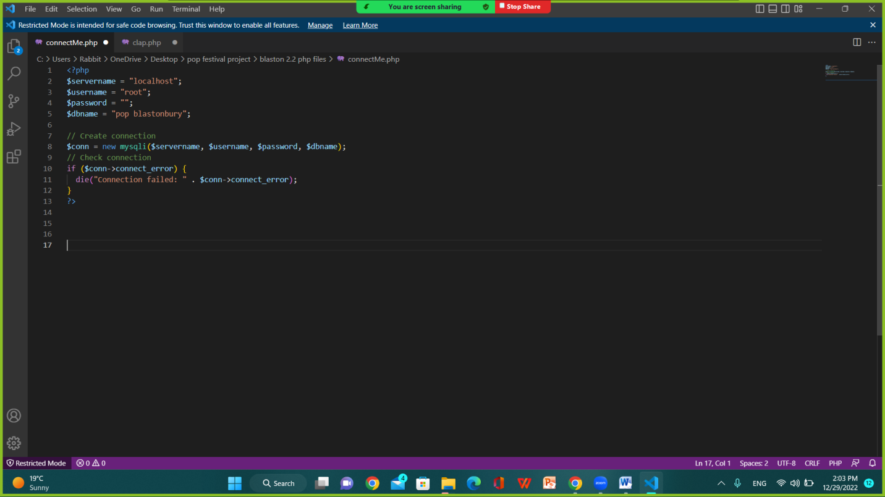

**PART (3)**

**MYSQL – JAVA**

* **Q) 3.1:** USING JDBC.

